Harry Potter and the Straight Line Spell
Written by: Clara Vu

Choose the letter of the correct answer. For all questions, NOTA means “none of the above”.

1. During Quidditch practice, Fred and George fly in paths that are coplanar, and do not intersect. What is the best way to describe the relationship between their paths?
A. Skew B. Perpendicular C. Parallel D. Non-coplanar E. NOTA

2. Ron’s wand broke! It just so happens that it broke along point A, which is the midpoint of his wand. If one of the pieces of his wand is 20 cm, how long is his wand?
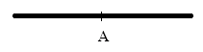
A. 20 cm B. 30 cm C. 40 cm D. 50 cm E. NOTA

3. Harry and Ron are doing a proof. Help them figure out what is missing.

Given: 2x+5=23

Steps | Reason
1. 2x+5=23 | 1. Given
2. 2x=18 | 2. Subtraction Property
3. x=9 | 3. ?

A. Multiplication Property of Equality
B. Distributive Property
C. Midpoint Theorem
D. Division Property of Equality
E. NOTA

4. Hermione, Ron, Harry, and Neville are studying their properties. They are discussing the following property:
If a=b and b=c, then a=c
Hermione says that this property is called the reflexive property. Ron insists that it is the transitive property. Harry thinks it is the symmetric property, while Neville believes it is the multiplication property of equality. None of them seem to agree! Who is right?

A. Harry B. Neville C. Ron D. Hermione E. NOTA

5. If Harry gets an A on his Potions exam, then he is happy. What is the inverse of this if-then statement?

A. If Harry gets an A on his Potions exam, then he will get an A on his Defense Against the Dark Arts exam
B. If Harry is happy, then he gets an A on his Potions exam
C. If Harry does not get an A on his Potions exam, then he is not happy
D. If Harry gets an A on his potions exam, then Ron is happy
E. NOTA

6. Ginny is trying to prove two triangles to be congruent. She learned in class different ways to prove triangle congruent. Which of these is NOT one of them?

A. AAA B. SSS C. ASA D. SAS E. NOTA

7. The top of a tower at Hogwarts is shaped like a regular square pyramid. How many possible planes are there?
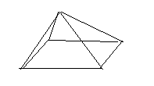
A. 3 B. 4 C. 5 D. 6 E. NOTA

8. The top of a witch’s hat can be flattened to form an equilateral triangle. The line drawn inside the triangle from one of the vertices to the opposite side can be called any of the following EXCEPT:
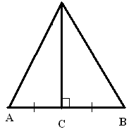
A. Altitude B. Median C. Perpendicular Bisector
D. Base E. NOTA

9. Referring to the figure in number 8, which of the following conclusions can Ginny logically draw from the fact that it is an equilateral triangle?

A. It is a also a right triangle B. It is equiangular C. It is a scalene triangle
D. It is an obtuse triangle E. NOTA

10. Referring to the figure in number 8, if the length of AB is 4x+18 cm, what is the length of AC, in terms of x?

A. 9 B. 2x+9 C. 2x+ 18 D. 8x+36 E. NOTA

11. Harry is playing Quidditch. He is at point H. He spots the Golden Snitch, which is traveling along line S. Harry wants to get to the Snitch using the quickest path possible. Which of the following paths has the shortest distance?
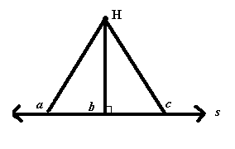
A. Path a
B. Path b
C. Path c
D. Each path has the same distance
E. NOTA

This figure is a side view of one of the cars on the Hogwarts Express train. It is a parallelogram. Use this figure for questions 12-15.
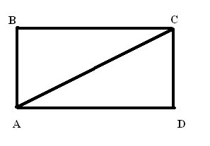

12. If mBCA is 30, then what is the mDAC?
A. 30
B. 45
C. 60
D. 90
E. NOTA

13. BCA and DAC can be best described as:

A. Alternate interior angles
B. Right angles
C. Same-side interior angles
D. Corresponding angles
E. NOTA

14. If ABC is congruent to CDA, and AB is 9 feet, then how long is CD?

A. 9 inches
B. 4.5 feet
C. 9 feet
D. 18 feet
E. NOTA

15. Hermione is trying to prove that ABC is congruent to CDA. She states that AC AC, but she can’t remember what property this illustrates. What is it?

A. Symmetric Property
B. Addition Property of Equality
C. Transitive Property
D. Reflexive Property
E. NOTA

16. Ron’s piece of parchment is a rectangle. Hermione’s is a rhombus., and Harry’s is a square. Which of the following statements are always true?
I. Every rectangle is a square
II. Every square is a rectangle
II. Every rhombus is a square
IV. Every rhombus is a rectangle
A. I only
B. II only
C. I, II, III only
D. all of them are true
E. NOTA

17. A diagonal is drawn on Harry’s square piece of parchment.
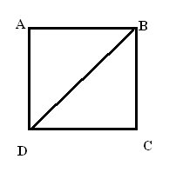
What is the mABD?

A. 30
B. 45
C. 60
D. 90
E. NOTA

18. Using the figure in number 17, what is the mBCD?

A. 30
B. 45
C. 60
D. 90
E. NOTA

Two owls are flying outside. One is traveling along line A while the other is flying along line B. Their paths cross at X. Refer to this figure for questions 19-22.

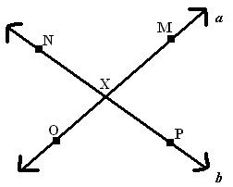

19. If the mMXP is 3y-5, and mNXO is 70, then what is x?

A. 15
B. 25
C. 73/3
D. 155/3
E. NOTA

20. Suppose: mOXN=y+z
mNXM=z+10
If y=3z, then z=?

A. 18
B. 34
C. 46
D. 108
E. NOTA

21. NXM and OXP can be best described as what kind of angles?

A. Supplementary
B. Complementary
C. Adjacent
D. Right
E. NOTA

22. NXM and MXP can be best described as what kind of angles?

A. Supplementary
B. Vertical
C. Right
D. Complementary
E. NOTA

23. Harry is making a potion. It asks for:

X+10 cups of frog juice
2X+4 cups of crushed toadroot
X cups of dried tuggleroot
Snape gives Harry the following equation to solve for X: 5X+2=32
How much tuggleroot should Harry get?

A. 34/5 cups
B. 6 cups
C. 5 cups
D. 16 cups
E. NOTA

24. If Ron doesn’t eat chocolate, then he is hungry. What is the converse of this if-then statement?
A. If Ron doesn’t eat chocolate, then he is not hungry
B. If Ron is not hungry, then he ate chocolate
C. If Ron is hungry, then Ron doesn’t eat chocolate
D. If Ron doesn’t eat chocolate, then Hermione will
E. NOTA
25. Ron tells Harry, “If it‘s a Monday, then Hermione is cranky.” Harry replies, “But last Monday Hermione was in a good mood!” Harry’s statement is an example of what?

A. inverse
B. converse
C. hypothesis
D. counterexample
E. NOTA

Use the following information and figure for questions 26-28. Harry, Hermione, Ron, and Neville are walking in a straight line. Harry is at point A, Hermione is at point B, Ron is at point C, and Neville is at point D. C is the midpoint of AD and B is the midpoint of AC.
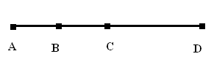

26. If the distance between A and D is 4 feet, how far apart are A and C?

A. 1 foot
B. 2 feet
C. 4 feet
D. 8 feet
E. NOTA

27. If the distance between A and C is 6X-12, then what is the distance between A and B in terms of X?

A. 2X -4
B. 3X+6
C. 3X-6
D. 12X-24
E. NOTA

28. If AD is 12, then what is AB?

A. 3
B. 4
C. 6
D. 24
E. NOTA

29. Hedwig is flying to Hogwarts to deliver a package to Harry. The package is in the shape of the following trapezoid:
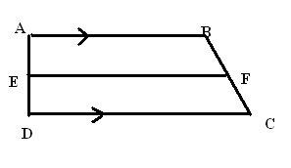
If EF is the median, and AB is 7 and DC is 9, what is EF?

A. 1
B. 4
C.8
D. 16
E. NOTA

30. Malfoy stole Harry’s wand! Hermione and Ron try to help Harry get it back. They want to surround Malfoy in the shape of a right triangle (with Hermione at point A, Ron at point B, and Harry at point C), with Malfoy equidistant from all three points. If the distance between Hermione and Ron is 8 feet, what is the distance between Malfoy and point Harry?
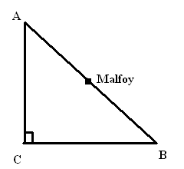
A. 2 feet
B. 4 feet
C. 8 feet
D. 16 feet
E. NOTA

ANSWER KEY

- C
- C
- D
- C
- C
- A
- E (7)
- D
- B
- B
- B
- A
- A
- C
- D
- B
- B
- D
- B
- B
- E (vertical)
- A
- B
- C
- D
- B
- C
- A
- C
- B

